### Instructions:

For the [presentations on the 16th of June](https://agtools.app/decision_analysis/#section-seminar_schedule) we expect to see your conceptual models in detail and a peek at the code. Please take 5-10 minutes to tell us about the decision maker, the decision, and what you are modeling. Show us a nice overview of the decision problem and your conceptual model of it and your next steps -> which outcomes are you focused on? Which inputs will you need to gather? Which assumptions have you made? What are the sources for your assumptions about relationships in the model? How far along are you with the accompanying model code?

Why rice?

Rice feeds the majority of the world’s population and employs millions, especially in developing countries in the Global South (Muthayya et al., [2014](https://www.nature.com/articles/s41599-022-01394-z#ref-CR143)). Rice consumption has increased globally over the last decade. Statista data show that, in the cropping year 2020/2021, the world population consumed about 504.3 million metric tons of rice, increasing from 437.18 million metric tons in 2008/2009 (Shabandeh, [2021](https://www.nature.com/articles/s41599-022-01394-z#ref-CR195)). These data highlight the crop’s global contribution and importance, especially in realizing the Sustainable Development Goals (SDGs), the blueprint for global prosperity (Gil et al., [2019](https://www.nature.com/articles/s41599-022-01394-z#ref-CR78)). The SDGs call for systems transformation, including in agriculture, guided by the principles of sustainability and equity, driven by the leave-no-one-behind aphorism, to address the root causes of perennial poverty and chronic hunger. [Two decades of rice research in Indonesia and the Philippines: A systematic review and research agenda for the social sciences | Humanities and Social Sciences Communications (nature.com)](https://www.nature.com/articles/s41599-022-01394-z)

* Most rice fields in Southeast Asian countries (SEA) are fragmented with small plot sizes of 0.1–2.0 hectares (ha).
* Small-sized and unleveled fields hamper mechanization and cause low energy efficiency and productivity in mechanized operations that can be counteracted by the benefits of using a combine harvester.
* Expanding field size or removing field bunds is one of the key strategies for more effective farming in several countries. For instance, the [“small farmer, large field”](https://ricetoday.irri.org/piloting-the-vietnamese-small-farmers-large-field-scheme-in-eastern-india/) program is one of the promoted models of agricultural structural transformation in Vietnam. <https://ricetoday.irri.org/precision-land-leveling-for-sustainable-rice-production-case-studies-in-cambodia-thailand-philippines-vietnam-and-india/>

“Small farmers, large fields”

Participating farmers organize themselves into groups and synchronize their operations by adopting a single rice variety to plant, establishing a group nursery, and transplanting and harvesting around the same time, thus essentially converting their small landholdings into a large field. The SFLF schemes in Vietnam range from formal arrangements, in which farmers set up a company structure and become shareholders, to informal synchronization of activities. <https://ricetoday.irri.org/piloting-the-vietnamese-small-farmers-large-field-scheme-in-eastern-india/>

Why Laser Leveling?

Laser land leveling (LLL) is a laser-guided technology used to level fields by removing soil from their high points and depositing it in their low points. LLL reduces greenhouse gas emissions by saving on energy, reducing cultivation time, and improving input-use efficiency. In a level field, water is distributed evenly, thus, reducing the amount of time and volume of water needed for irrigation (Mitigation technologies, IRRI). <https://www.researchgate.net/publication/353366028_One_Must_Do_Five_Reductions_Technical_Practice_and_the_Economic_Performance_of_Rice_Smallholders_in_the_Vietnamese_Mekong_Delta>

Land leveling using laser-guided leveling equipment is adapted well-tested, easy to implement and efficient technology for **saving water**, **improving water distribution**, and **increasing irrigation water use efficiency.**

The empirical results from the study by Aryal (2015) indicated that laser leveling in rice fields reduced irrigation time by 47–69 h/ha/season and improved yield by approximately 7 %, compared with traditionally leveled fields. <https://www.researchgate.net/publication/353366028_One_Must_Do_Five_Reductions_Technical_Practice_and_the_Economic_Performance_of_Rice_Smallholders_in_the_Vietnamese_Mekong_Delta>

Which country?

| Country | Rice agricultural land production | %Smallholders farmers on total farmers | Medium and Big scale farmers |
| --- | --- | --- | --- |
| Philippines | 9.67Mha | 5M |  |
| Thailand | 10.5Mha | 26.5% |  |
| Vietnam | 7.5Mha | 10M |  |
| Indonesia | 12.2Mha | 93% |  |

Viet Nam - rice is the principal commodity

Thailand - second commodity

Philippines - second commodity

Indonesia - second commodity(first is sugar cane) **BUT ALSO third top global producer**

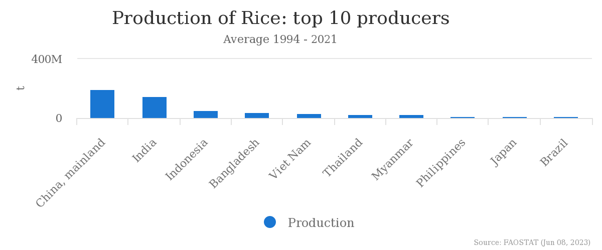

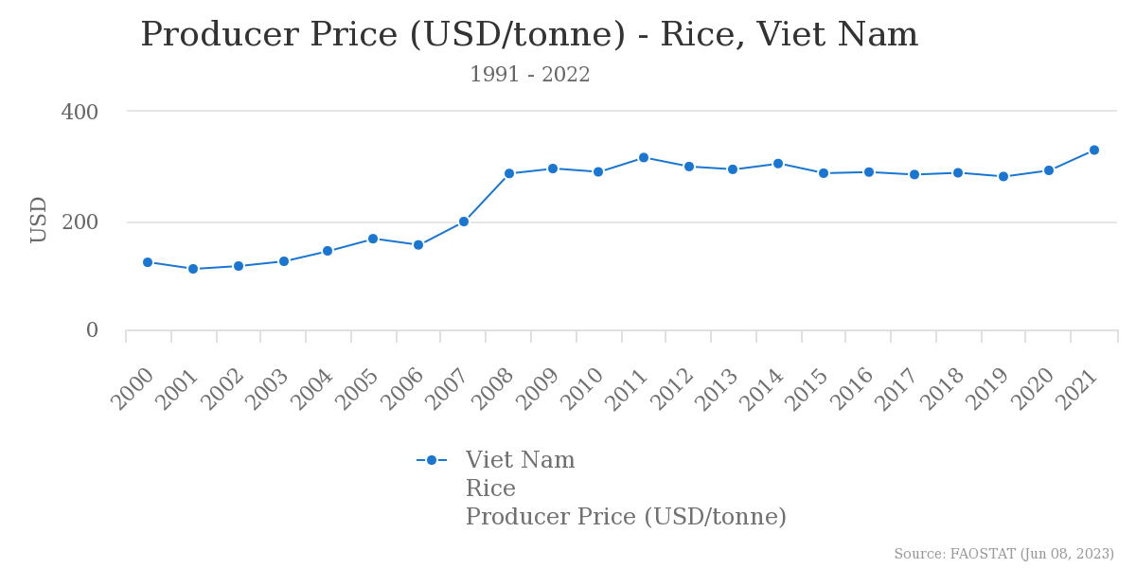

Laser leveling implementation:

* Philippines
* Thailand
* Vietnam

IRRI program with good economic impacts

* Indonesia

**Supporting policies:**

* Vietnam

Since 2004, Vietnam government has issued policies to support farmers to buy machines for agricultural production using budget’s provinces. 30 provinces and cities implemented the supporting policy. Another financial policies like tax has many changes; For ASEAN countries: tax rate since 2010 for imported agricultural machines is 0%, or 5% in some cases: the government also gave priorities to investment under the Key Program of Mechanization to manufacture more tractors and agricultural machines (Viet, 2012)

<https://www.researchgate.net/publication/343514085_Current_Perspective_of_Mechanization_Level_and_Its_Supporting_Policies_in_Asia>

Environmental factors

* Vietnam ranked second (430 kg/ha) after China (503 kg/ha), in terms of fertilizer consumption, while other countries, such as India (166 kg/ha), Thailand (162 kg/ha), and the Philippines (157 kg/ha), consume relatively low amounts of fertilizers per hectare of arable land (FAO, 2016).
* Each year, over 10 million tons of fertilizers are consumed in Vietnam, of which 80% are supplied by domestic factories. Approximately 60.6% of this amount is used to cultivate rice.
* A recent report by the Vietnam Environment Administration (Ministry of Natural Resources and Environment) states that, on average, Vietnam uses 15,000–25,000 tons of pesticides each year. There is also proof that farmers and communities that use water sources with pesticide residues, i

**“One Must Do, Five Reductions” (1M5R)**

Technological package that was developed by the IRRI’s Consortium and promoted by the World Bank’s Agricultural Competitiveness Project.

Farmers who apply this technique are promoted to use certified seeds (One Must Do) and reduce the seed rate, use of fertilisers and pesticides, irrigation cost, and post-harvest losses (Five Reductions). In particular, this advanced technology is expected to be the best practice for intensive rice production

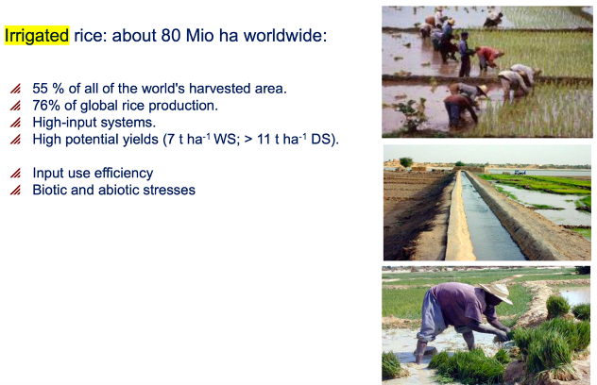

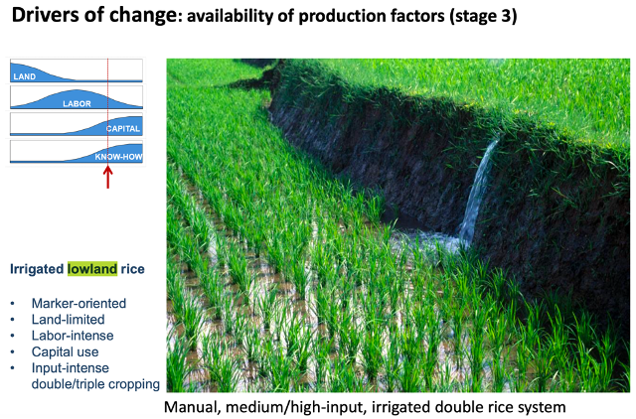

Laser-Leveling

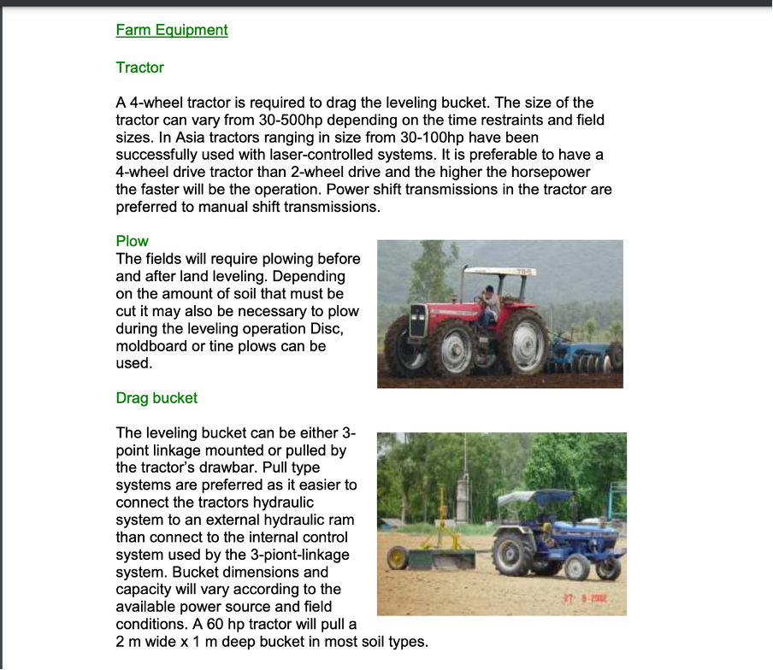

### Conceptual model

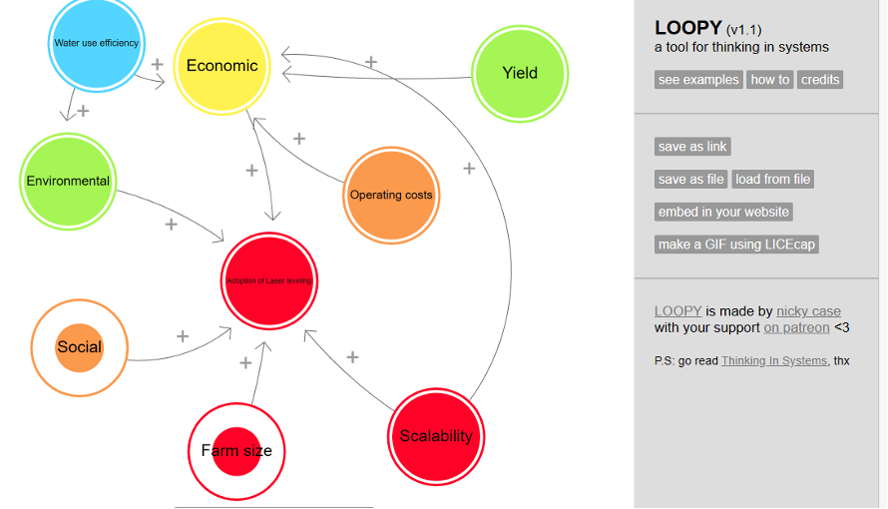

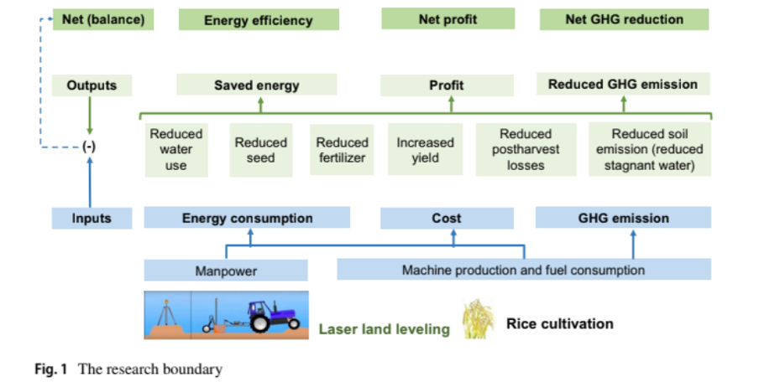

Source: https://drive.google.com/file/d/1Lj4Ij-4uyMEdVQpIT-gbcKnMMJLrs_PZ/view?usp=sharing

Input- laser leveling (compare laser leveled to non leveled)

Output- farmers adopting laser leveling

Outcome- improving economic activity/efficiency, labor-saving production

Impact- Income increase for farmers, more efficient use of water, soil conservation, reduced GHG emissions (less methane), increase ofland use efficiency

Long term goal- efficient resource distribution, land sparing, increased resilient vs. drought/climate change, agricultural mechanization efficiency, food security, sustainability

* Decision maker- farmer (cooperative of smallholder farmers in Asia )
* Decision- is laser leveling a good technique **for me** (as farmer) in comparison to my conventional rice production? As a rice farmer cooperative in Vietnam should we invest in laser leveling technology for our fields?

Laser leveling implementation

* Outcomes-

More efficient use of resources, and sustainable farming

* Assumptions (relationships)-
* Smallholder farmers will agree to consolidate their lands (this increases production efficiency), and are part of cooperatives
* Mechanization level and Supportive policies in Asia (Country)
* Low Carbon Rice farming practice
* Laser leveling is a scale neutral technology i.e., not biased towards large farmers
* Sources of assumptions

Land consolidation, rice production, and agricultural transformation: Evidence from household panel data for Vietnam

https://www.sciencedirect.com/science/article/abs/pii/S0313592622001941

Current Perspective of Mechanization Level and Its Supporting Policies in Asia

<https://www.researchgate.net/publication/343514085_Current_Perspective_of_Mechanization_Level_and_Its_Supporting_Policies_in_Asia>

Factors affecting adoption in Haryana, India (rice-[wheat systems](https://drive.google.com/file/d/1bwS57KgsQO7BxZwHoBAWTCUtCJ4Yt5Mc/view?usp=sharing))-> *farm size* (larger farms more likely to adopt). Information about technology through farmer-to-farmer communication and through private traders, *participation in agricultural training* and *membership in local agricultural institutions* increased both the likelihood and the intensity of adoption. There is negative association between land holdings and the proportion of laser-leveled land. Conclusion: *closer collaboration* among the various stakeholders, to promote *farmer-to-farmer communication* through i*ncreased participation in local institutions* and increase the rate of adoption

<https://www.tandfonline.com/doi/abs/10.1080/15427528.2018.1457584>

Scalability (rice-wheat, [Northwest India](https://drive.google.com/file/d/1921TWo76tej9OxVR6hCPfNHxUwOlmuhU/view?usp=sharing)): LLL is a scale neutral technology i.e., not biased towards large farmers

Key factors affecting speed of adoption ([Punjab, Pakistan](https://drive.google.com/file/d/1fdPDBgxOeaVL5H1W-WXuGhMAYrUbp5Ij/view?usp=sharing)): strong legal land rights, access to information about the technology, and exposure to the technology. Long distance to rental market deaccelerates the speed of adoption (logistics). Conclusion: improving access to extension services, exposure to innovation, and legal land rights can enhance the adoption and diffusion of the technology.

Sufficient capital for purchase of tractor and leveling equipment is either inaccessible/expensive. Formal lenders in the region of focus charge close to 20% interest for microloans, while informal rates jump to as high as 35% in [India and Pakistan](https://events.development.asia/system/files/materials/2012/04/201204-developments-precision-agriculture-use-asia.pdf). Solution: subsidies to borrowers

Attitude towards water and soil resources conservation and environmental beliefs had the highest direct effect on individual perception toward impacts of laser leveling adoption in [Iran](https://lsspjournal.biomedcentral.com/articles/10.1186/s40504-020-0097-2).

### Code

### Next steps

### Powerpoint draft

Link: <https://www.canva.com/design/DAFlPXkT3RU/PCtZFI1sw7j5KjPmi6DVww/edit?utm_content=DAFlPXkT3RU&utm_campaign=designshare&utm_medium=link2&utm_source=sharebutton>